Table of Contents

**🕯️ Magha Puja – Detailed History in Buddhism** 1

**📅 When It Is Celebrated:** 1

**📖 Historical Background:** 1

**🧘 Teachings Given:** 1

**🌸 Importance of Magha Puja:** 1

**🛕 Modern Practices:** 1

**🌍 Symbolism:** 2

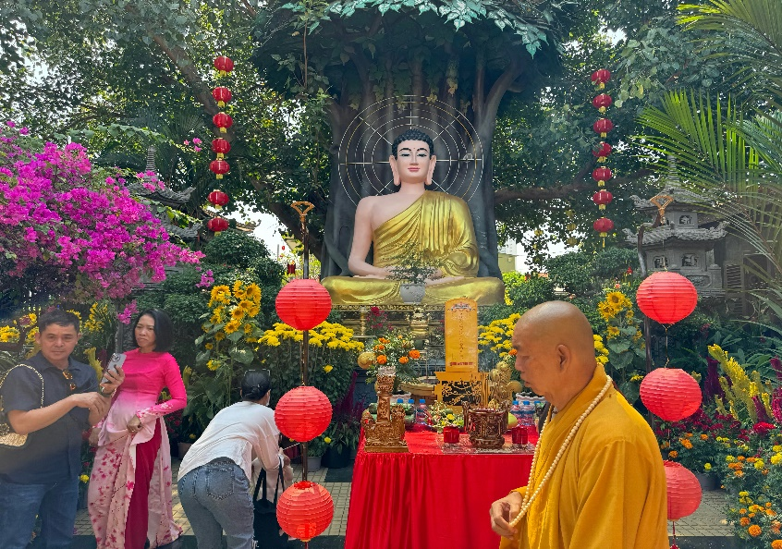

**🕯️ Magha Puja – Detailed History in Buddhism**

**📅 When It Is Celebrated:**

Magha Puja is observed on the full moon day of the **third lunar month** (Magha), which usually falls in **February or March**. In 2025, Magha Puja will be celebrated on **February 12, 2025**.

**📖 Historical Background:**

Magha Puja, also known as **Sangha Day**, commemorates a remarkable event in the early Buddhist community. This day marks the spontaneous gathering of **1,250 enlightened monks (Arahants)** at **Veluvana Bamboo Grove**, Rajgir (India), where they came to pay respect to **Lord Buddha** without any prior arrangement.

This sacred meeting is known as the **Fourfold Assembly** and is special because:

1. **All 1,250 monks were Arahants** – fully enlightened.
2. **They were all ordained by the Buddha himself**.
3. **They assembled on the full moon day of Magha**.
4. **Buddha gave the "Ovada Patimokkha" sermon** – a summary of his teachings.

**🧘 Teachings Given:**

On this day, Lord Buddha delivered a powerful sermon called the **Ovada Patimokkha**, which outlines the core principles of Buddhism:

* **Do no evil**
* **Do good**
* **Purify the mind**

This became a foundation for monastic discipline and Buddhist ethical life.

**🌸 Importance of Magha Puja:**

* It's a day of **renewal, reflection, and gratitude** for the Buddhist community.
* Considered the **second most sacred Buddhist festival** after Vesak.
* Encourages followers to practice **meditation, charity, and morality**.

**🛕 Modern Practices:**

In countries like **Thailand, Sri Lanka, Cambodia, Laos, and Myanmar**, people:

* Visit temples
* Offer food to monks
* Join candlelight processions around stupas
* Recommit to the Five Precepts

**🌍 Symbolism:**

Magha Puja reflects the **unity and harmony** of the Sangha (Buddhist monastic community) and the importance of living a virtuous life guided by wisdom and compassion.